History of the Americas HL IA
Historical Investigation
Section 2: Investigation
Revision

Overview of components
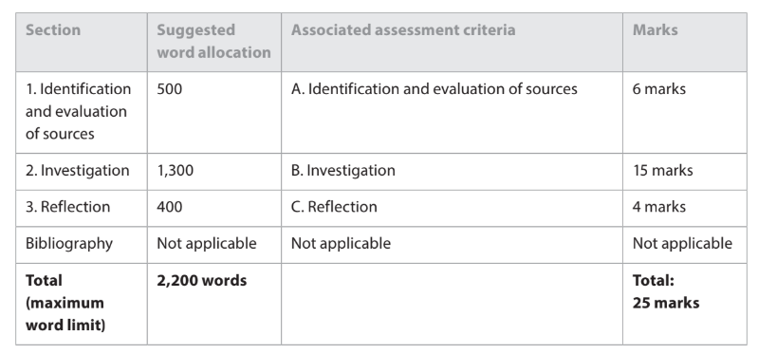
Criterion A - Identification and evaluation of sources (4-6 markband) ~500-word allocation
- An appropriate question for investigation has been clearly stated. The student has identified and selected appropriate and relevant sources, and there is a clear explanation of the relevance of the sources to the investigation.
- There is a detailed analysis and evaluation of two sources with explicit discussion of the value and limitations of two of the sources for the investigation, with reference to the origins, purpose and content of the two sources.

Criterion B - Investigation (13-15 markband) ~1,300-word allocation
- The investigation is clear, coherent and effectively organized.
- The investigation contains well-developed critical analysis that is focused clearly on the stated question. Evidence from a range of sources is used effectively to support the argument.
- There is evaluation of different perspectives. The investigation argues to a reasoned conclusion that is consistent with the evidence and arguments provided.

Criterion C - Reflection ~400-word allocation
- The reflection is clearly focused on what the investigation highlighted to the student about the methods used by the historian
- The reflection demonstrates clear awareness of challenges facing the historian and/or limitations of the methods used by the historian.
- There is a clear and explicit connection between the reflection and the rest of the investigation.

Paragraph Diagnostic and Revision
Instructions:  Paste your research question in the box below. Pick your longest body paragraph in Section 2 and paste it below your research question.  - Highlight in yellow the sentence(s) containing the key idea.  - Highlight in blue the transitional words or phrases throughout your paragraph.  - Highlight in orange the sentence(s) or phrase(s) that connect your key idea to the specific arguments, evidence, or data you will cite.  - Bold where identify the source(s) you quote or reference. Look for:  - Name of author or producer  - If a historian, classify their specialization or school of thought, e.g., “Economic historian John Doe,” or “Historian of Hellenistic Greece”  - If a primary source, give the date, identifying information about the producer, and the genre  - Every quotation is embedded (“quotation sandwich”)  - Highlight in pink directly cited data or quoted information.  - Highlight in purple the sentence(s) connecting the data back to the R.Q.. These sentences explain what part of the answer, or contribution toward the answer, you draw or conclude from the cited data or information.  - Highlight in green any sentences that do not connect or relate to the key idea already highlighted in yellow. | Example from IB assessed student work:  RQ: To what extent was the Soviet invasion of Afghanistan in December 1979 strategically motivated?  In addition, the Soviet Union had broader strategic ambitions for central Asia and Afghanistan’s location was vital to these plans. Afghanistan would provide a secure base for further advances into the Middle East and South Asia,^ and facilitate control of key commodities such as oil.^ Historian Milan Hauner argues that the Soviet invasion stemmed from its desire to gain control of warm water ports and the Gulf oilfields.^ This view is supported by the historian Richard Pipes, who asserts the intervention was to progress the Soviet ambition to gain influence in the south “in the direction of the Persian Gulf.”^ Furthermore, if the USSR failed to respond to the power struggle in Afghanistan, it would harm its credibility and reputation as a world superpower. The Soviets could not “abandon”^ the territory and permit its fall to outside influence as it would weaken the USSR’s regional status.^

Global Revision for Structure
- Now go through your entire Section 2. In each paragraph, highlight in yellow sentence(s) containing the key idea. Highlight in green any sentences in each paragraph that do not directly connect or relate to that paragraph’s key idea already highlighted in yellow.
- Copy and paste all yellow-highlited and green-highlighted sentences in sequential order below.

Classify how each point contributes to answering your research questions with reference to the six concepts of IB History:
Change, Continuity, Causation, Consequence, Significance, Perspectives

Does the ordering of the paragraphs follow your roadmap? Would your argument benefit from reordering the paragraphs and revising the roadmap?

Argument Structures to Consider
Nestorian Order:
Second strongest point + examples, minor points + examples
Opposing theory/point + examples
Refute opposition by arguing counter points + examples
Strongest, best point + examples

Rogerian argument:
Introduce historical issue fairly and neutrally
Explain opposing views fairly + supporting examples
State your historical proposition/position; give strong reasons + compelling supporting examples
State your position’s advantages or offer a logical compromise

NEED TO CUT WORDS? Try this exercise!

Global Revision approaches for your Historical Investigation
What it says  (organization of content) | What it does  (functional structure)
Paraphrase, summarize, or outline only the content of the paragraphs of your investigation  (alternatively, copy and paste each paragraph into a table like this one)  Check for coherence:  - In the first paragraph, italicize+underline the key terms stated in your research question, thesis, and roadmap  - Italicize+underline those same terms as you encounter them in the body paragraphs of your paper  - Underline other words related to the terms and the main point each paragraph argues relevant to answering your research question  *  Transitions: Do your paragraphs begin with words that signal how the paragraph relates to the one before it? (Alternatively: Paragraphs may end with words that signal how the following paragraph relates to it.)  Check for strong, accurate Transitional words and phrases.  *  List out the argumentative components in each paragraph: claim, reason, evidence (refer to your primary and/or secondary sources!), acknowledgement & response  *  Make sure you’ve properly embedded quotations/ incorporated evidence AND analyzed them with respect to your argument  This Quotation Sandwich model applies well to quoting sources as well as information paraphrased or referenced from sources.  Check too for proper in-text citations (Author #) and make sure the matching full reference is listed on your bibliography or works cited page. PurdueOWL MLA Guide here - but don’t use the automatic generator! Just fill in the formatted elements for each citation yourself!! It can be helpful to use a sample bibliography as a model. | List or map out how each part of the paragraphs’ content advances your historical investigation of the question toward your well-argued and well-supported answer.  You might consider or classify how each point contributes to answering your research questions with reference to the six concepts of IB History:  Change, Continuity, Causation, Consequence, Significance, Perspectives  *  Does the ordering of the paragraphs follow your roadmap? Would your argument benefit from reordering the paragraphs and revising the roadmap?  *  Next to each part of the content, list which component of the section 2 assessment criteria it corresponds to and how/why.  - Develops critical analysis that is focused clearly on the stated question  - Argues toward a reasoned conclusion that answers/responds to the question  - Effectively uses evidence to support the argument  - Uses evidence from a range of sources across the paragraphs of the investigation  - Evaluates different perspectives

Subject report (May 2024) - Criterion B: Investigation
Identifying different schools of thought associated with the authors
Villanova’s Falvey Library on historical schools/approaches:

Selected historical schools/approaches:
- Period and/or Geographic specialization
- Social history
The French Annales School was one of the early representatives of this trend.
- Environmental history
- World history
- Economic history
Marxist history may be considered as part of this school of thought.
- Cultural history
- Gender history
- Subaltern studies
- Ethnohistory
- History of ideas
- Linguistic history

Templates for Embedding Quotations
(from Gerald Graff and Cathy Birkenstein, They Say/I Say: The Moves that Matter in Academic Writing, 5th ed., W.W. Norton & Co., 2021)

CAPTURING AUTHORIAL ACTION  X acknowledges that __________.  X agrees that __________.  X argues that __________.  X believes that __________.  X celebrates the fact that __________.  X claims that __________.  X complains that __________.  X concedes that __________.  X demonstrates that __________.  X denies/does not deny that __________.  X deplores the tendency to __________.  X emphasizes that __________.  X insists that __________.  X observes that __________.  X questions whether __________.  X refutes the claim that __________.  X reminds us that __________.  X reports that __________.  X suggests that __________.  X urges us to __________. | INTRODUCING QUOTATIONS  X states, “__________.”  As the prominent philosopher X puts it,  “__________.”  According to X, “__________.”  X himself writes, “__________.”  In her book, __________, X maintains that  “__________.”  Writing in the journal __________, X complains that  “__________.”  In X’s view, “__________.”  X agrees when she writes, “__________.”  X disagrees when he writes, “__________.”  X complicates matters further when he writes,  “__________.”  EXPLAINING QUOTATIONS  Basically, X is warning __________.  In other words, X believes __________.  In making this comment, X urges us to __________.  X is corroborating the age-old adage that  __________.  X’s point is that __________.  The essence of X’s argument is that __________.

Components of Academic Arguments
Claim: What do you want your reader to believe? What is your point?
Reason: Why do you say that? Why should your reader agree?
Evidence: How do you know? Can you back it up?
Acknowledgement & response: But what about…?
Warrant: How does that follow? Can you explain your reasoning?

Explore Multiple Perspectives
Have you explored the strongest relevant counterarguments?
Have you looked for examples or historical accounts that challenge or complicate your reasons?
Have you considered alternative interpretations of your examples?

